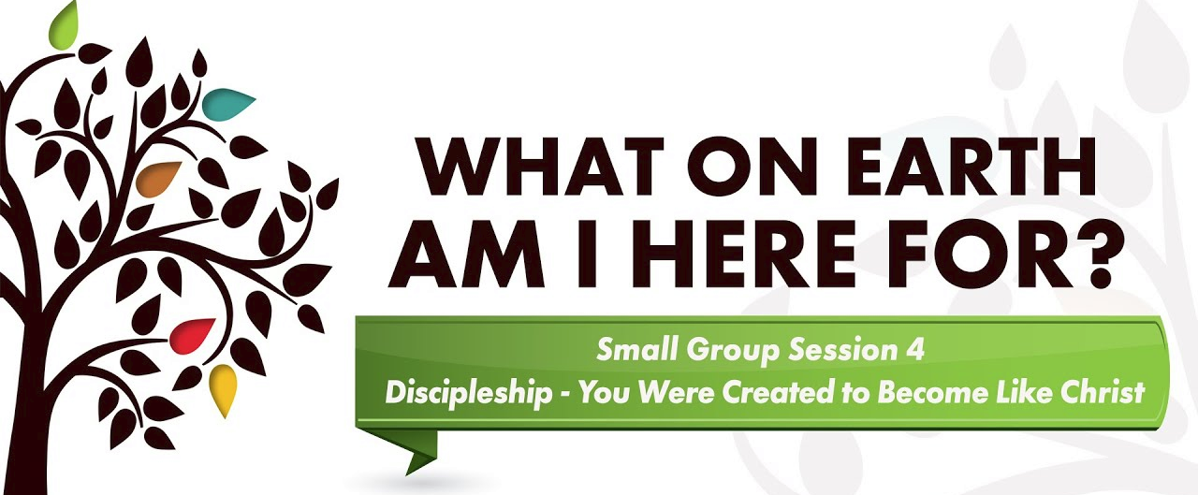

Discussion Questions:
1. How is the “What on Earth Am I Here For?” message series helping you to grow in Christlikeness?
2. What problem in your life has brought about the greatest growth in your character? How has a trial or tribulation helped you to trust God more fully?
3. What difficulty are you now facing that God can use to strengthen your walk with Him?
4. What lessons have you learned through the temptations that you’ve faced and God has helped you overcome?
5. When has a choice you made taken you away from God? When has a choice drawn you closer to Him and shaped your character in a godly fashion?
6. What tools has God placed at our disposal to resist temptation? Which do you find most useful?
7. Why is it so hard to forgive? What keeps us from forgiving others?
8. When has someone forgiven you? What effect did it have on your life?
9. How does knowing you’ve been forgiven by God affect your own willingness to forgive others? How does knowing God is in control impact your willingness to forgive others?
10. Is there anyone to whom you need to extend forgiveness right now? How might you do it?

Assignment:
Read chapters 22-28 of The Purpose Driven Life. Pick your favorite quote and share it.

GROW IN DISCIPLESHIP
Pick 1 small thing you can commit to doing to grow in discipleship this week

Discipleship is the process of becoming more like Christ.
God doesn’t just want you to know about Jesus, he wants you to become like Jesus.

Bible Study: In order to become like Jesus, we need to know what Jesus did and said. Join a Bible study or pick one of the Gospels and read it from beginning to end. To help you in your study, you may want to pick up a commentary or a study Bible that explains things verse by verse.
Build Meaningful Relationships: The number one thing that Jesus did was get involved in people’s lives. When you are a disciple, befriending someone isn’t taking on a project, you’re investing in a person. Learn to praise someone for the qualities that God is building into their life. Learn how to identify the good things in a person’s life and how to praise and affirm them in a healthy way.
Get involved in ministry: Look what Jesus did. He took His disciples and went throughout Galilee and Israel, ministering to people. He spoke to the masses; He healed; He cast out demons; He taught. For two and a half years, Jesus went about ministering, and He took the disciples with Him.
The ACTS Model of Prayer: A = Adoration. The first portion of our prayers should focus on adoring God for who he is and giving him honor and glory. C = Confession. A very basic part of prayer is self-examination and coming clean before God about our sin, confessing it, and then turning from it. T = Thanksgiving. Thanksgiving involves thanking God for who he is and what he has done. S = Supplication, which involves bringing our requests before God. This model helps us stay balanced in our prayers and attuned to the will of God.
Money Management: Take some time to look over how you manage your money. If you don’t have a budget you may want to establish one. Spend some time praying over what God wants you to do with the money he has given you. This will then help you budget with God’s priorities in mind.

