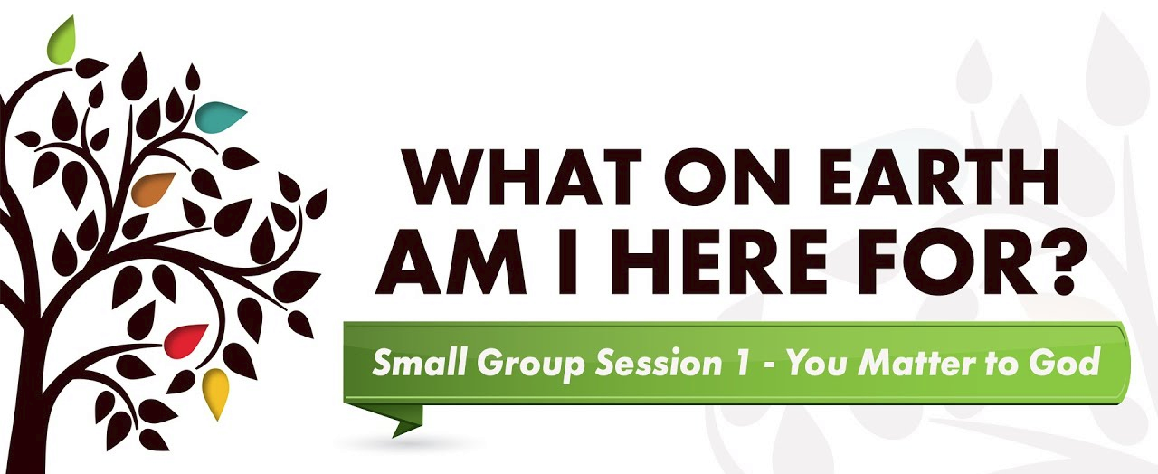

Small Group Guidelines
1. Focus your sharing on your own thoughts and feelings. Limit your sharing to 3-5 minutes.
In Purpose Driven Life, each one of us will be taking a close look at our current relationship with God and how we are living out the 5 Biblical purposes that He created us for. Avoid using this time to talk about our family members’, co-workers’ or others' problems. Use "I" "me" and "my" statements and avoid "you" or "we". The time limit gives everyone an opportunity to share and helps prevent any one person from dominating the group.
2. There is NO cross talk. Each person is free to express his/her thoughts and feelings without interruption.
Cross talk is when two or more people engage in a conversation that excludes or interrupts others. It includes making distracting comments or asking questions, speaking to someone else while another is sharing or responding to what someone has said during his/her time of sharing. We try not to interrupt thoughts or feelings.
3. We are here to support one another, not "fix" one another.
Our small group gatherings are not therapy sessions and we do not give advice or attempt to solve someone else's problem. We are here to share about what we feel God is telling us through the book and message series and to listen to each other.
4. What is shared in the group stays in the group.
We do not share information from the group with friends, family members or others outside of the group. This is called gossip. We respect others' right to share their information as THEY see fit. The only exception is if anyone threatens harm to themselves or someone else.
5. Offensive language has no place in a Christ-centered group.

Watch video segment

DISCUSSION QUESTIONS:
- What new insight did you gain from the video segment? What idea really grabbed hold of you?
- “God created me to love me.” When did you first hear about God’s love?
- “I was made to last forever.” How does that statement strike you? Are you encouraged, puzzled, disappointed, surprised?
- What difference would it make if you acted like life is all about God and not about yourself?
- What has happened in your life - the good, the bad, the ugly - that God has been able to use or may be able to use for His glory and in His service?

Fill out the Purpose Driven Life Health Assessment:
When done, pair up with a partner and share one purpose that is going well and one that needs a little work.

For Next Week:
Read days 1-7 of The Purpose Driven Life - mark any passages that jump out at you.

SPIRITUAL HEALTH ASSESSMENT
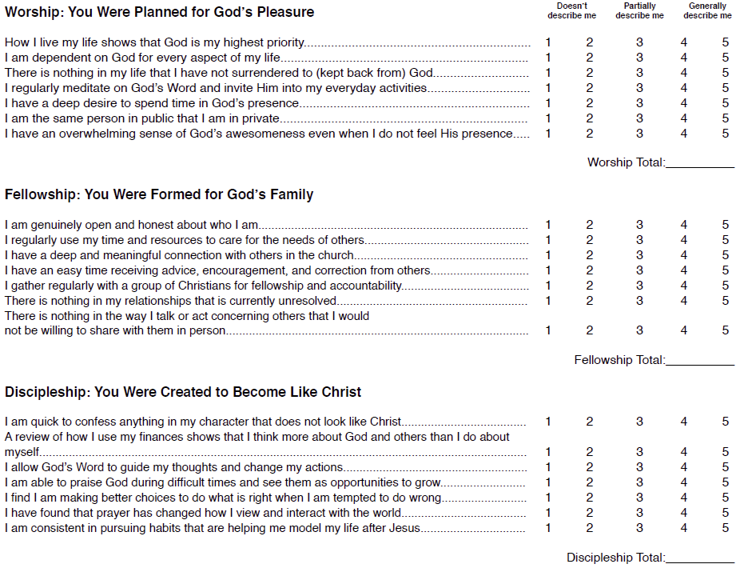
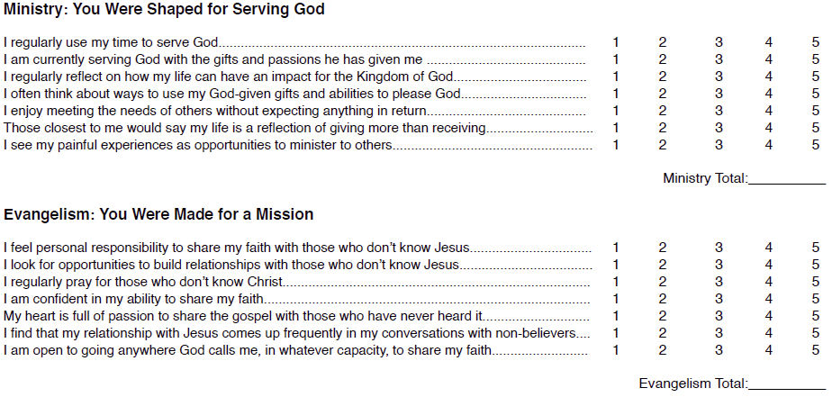
Please SAVE this sheet in your book for future reference

