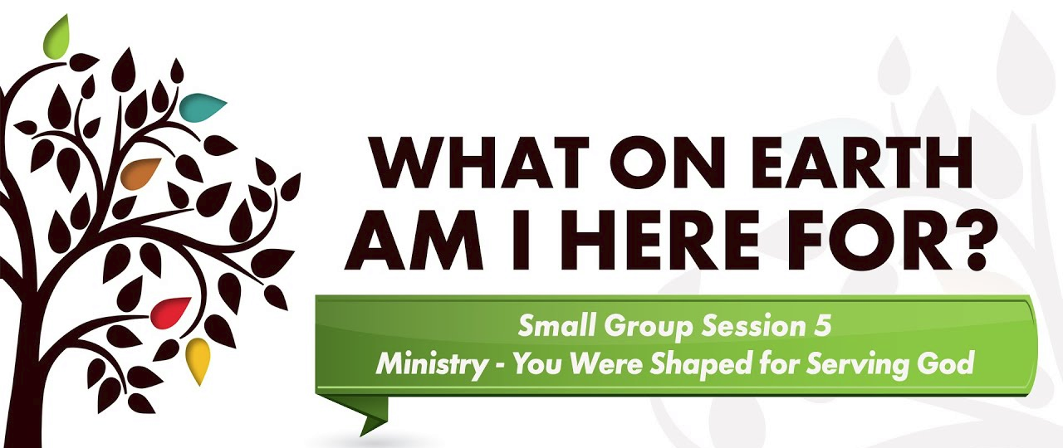

God “shaped” you for service:
Spiritual gifts, Heart, Abilities, Personality, Experiences

Discussion Questions:
1. What new insight did you gain from the video segment? What idea really grabbed hold of you?
2. What would our church look like if every member lived by the principle: “There is no such thing as a non-serving Christian”?
3. Have you ever missed a ministry opportunity because you were too busy?
4. When has an “interruption” in your life turned into a blessing for yourself or another person because you took the time to serve?
5. How do you view service and ministry? Is it a duty and obligation, or a joy and privilege?
6. Have you ever felt like giving up in a ministry situation? Did you – why or why not?
7. What do you think of the statement, “You can give without loving, but you cannot love without giving”? How have you experienced its truth? How is generosity an expression of love?
8. Have you ever prayed the “world’s most dangerous prayer – use me”? What happened?
9. Which of the four attitudes – availability, gratitude, faithfulness, generosity – do you need to work on the most? What specifically can you do to become more available, grateful, faithful, and generous in your service?
10. Do you know your SHAPE for ministry? In pairs, discuss: your spiritual gifts, your passions
(i.e. groups you like to help or causes you support), your abilities, your personality traits, and your experiences (family, educational, church, vocational, painful) and how these insights might affect how and where you serve. What is one thing you can do to serve in your church family?

Assignment:
Read Days 29-35 of The Purpose Driven Life. Pick your favorite quote and share it.

GROW IN MINISTRY
What step can you take to grow in ministry?

Join a Ministry: Join an existing ministry at your church that best fits your spiritual gifts, interests, passions, talents, abilities, personality type, and experiences.

Jump in Anywhere: You discover your gifts by getting involved in ministry. If you don’t know your gifts and abilities yet, then just find something that sounds interesting and get involved. You’ll never know what you’re good at until you get started. If it doesn’t work out, call it an “experiment” and try something else.

“If you wait for perfect conditions, you will never get anything done”
Ecclesiastes 11:4 (NLT).

Start a New Ministry: You may have an idea for a ministry that does not currently exist at your church. Spend some time in prayer to determine if this ministry idea is something you would like to pursue. If it is, then contact your pastor or church leader who is in charge of ministries.

Small Group Ownership: Write down on a sheet of paper all of the items it takes to make the group function on a weekly basis. The contacting, the setup, the prayer, the ice-breaker question etc. Then ask everyone to take one of the functions for the next 90 days so everyone has a little more ownership within the group.
Small Group Project: contact your church and see how your group could help serve as a team over the next 30 days. (Hospitality at a coffee hour, Hockey Game parking, church cleanup, etc)

Ministry is living a life that serves others and God, instead of only thinking about ourselves. Choose to discover how God shaped you, and how you can serve. There is joy in it!

